Order Of Service

Singing: Psalm 139b—CW page 117

Reading: Psalm 111

Opening Hymn: TLH 428

Reading: Hebrews 10:1-18

Request Hymn: CW Supplement 750

Reading: Luke 8:40-56

Sermon Hymn: TLH 262

Sermon Text: Acts 9:19b-25

In A Basket

Prayer

The Apostles’ Creed, TLH page 12

Holy Communion

The Lord's Prayer

The Blessing

Closing Hymn: TLH 577

************

Bible Study: Lambs: Snowy Owl
Sheep: Deut. 15:1-11
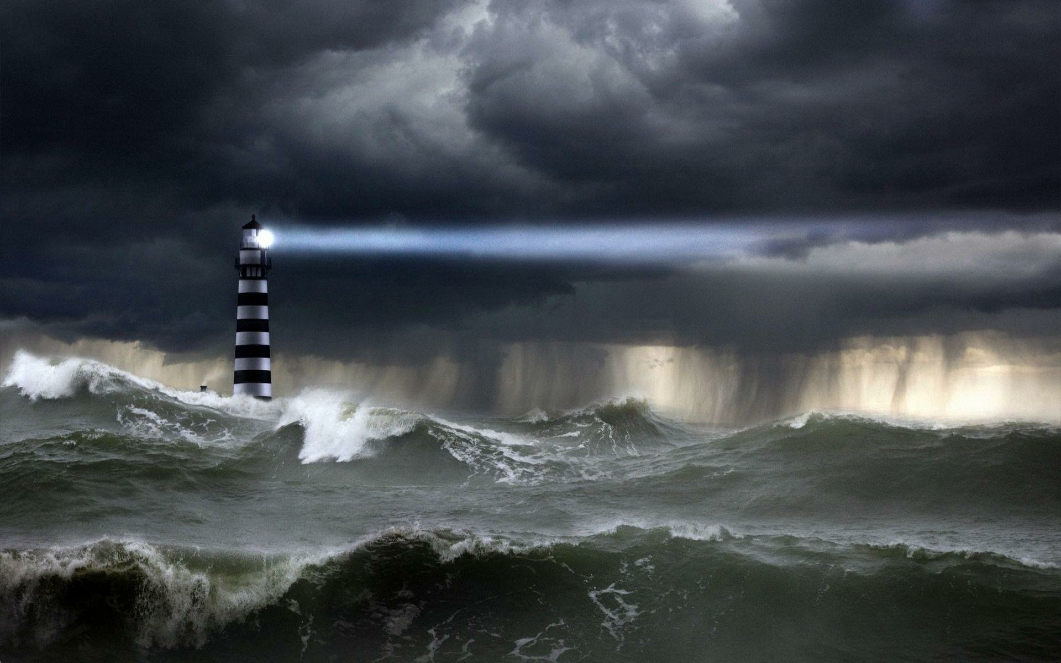

Storm At Sea

Water
Of
Life
27 October 2024

W A T E R O F L I F E

Independent Christian Church—Conservative Lutheran Doctrine

Worship Service: 9:30 a.m.

Larry Cooper, Pastor E-Mail address:
lcooper@wateroflife.cc
Web Site:
www.wateroflife.cc

* * * * * * * * * * * * * * * * * * * * * * * * * * *

Sermon Text: Acts 9:19b-25

In A Basket

* * * * * * * * * * * * * * * * * * * * * * * * * * *

19b Then was Saul certain days with the disciples which were at Damascus.
20 And straightway he preached Christ in the synagogues, that he is the Son of God.
21 But all that heard him were amazed, and said; Is not this he that destroyed them which called on this name in Jerusalem, and came hither for that intent, that he might bring them bound unto the chief priests?
22 But Saul increased the more in strength, and confounded the Jews which dwelt at Damascus, proving that this is very Christ.
23 And after that many days were fulfilled, the Jews took counsel to kill him:
24 But their laying await was known of Saul. And they watched
the gates day and night to kill him.
25 Then the disciples took him by night, and let him down by the wall in a basket.

